Programming Fundamentals

Assignment 02

Course Code: CS1002

Syed Muhammad Shuja Ur Rahman

Roll No. 22K-4456

Sir Shehzad

**Question 1**

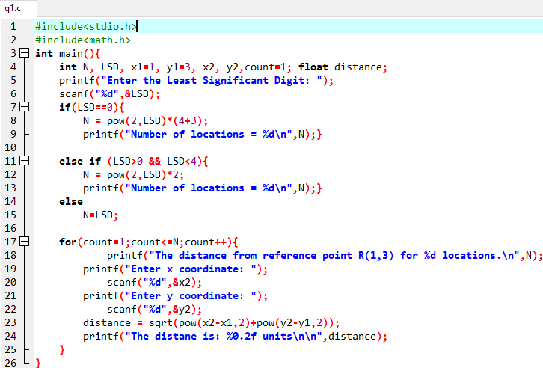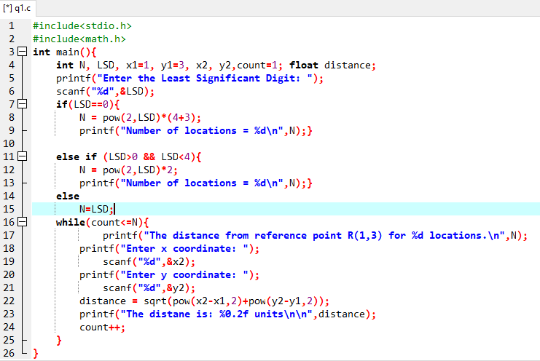A smart city which is equipped with the latest technologies such as self-driving cars (SD), robots, UAV, and many others is shown in Fig.1. Consider a UAV which is deployed to monitor the agriculture field and communicate with the robot, which can take an N number of different locations (A, B, C, and N). Develop a C-script that calculates the distance between reference point R (1,3) of a UAV and robot locations A, B, C, and N number of locations. N is the (non- zero) LSD of your mobile number. For 0 < LSD < 4 then take [N = (2LSD) *2], and if LSD = 0, take [ N = (2LSD) *4+3]. Note: (Use For loop and While Loop to accomplish this task).

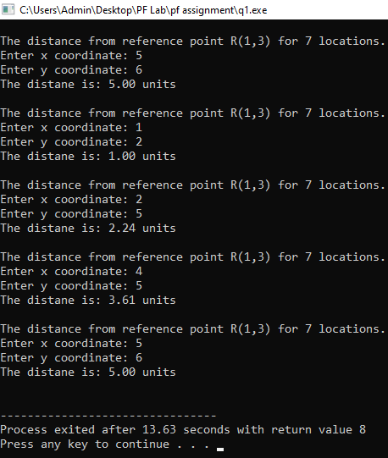

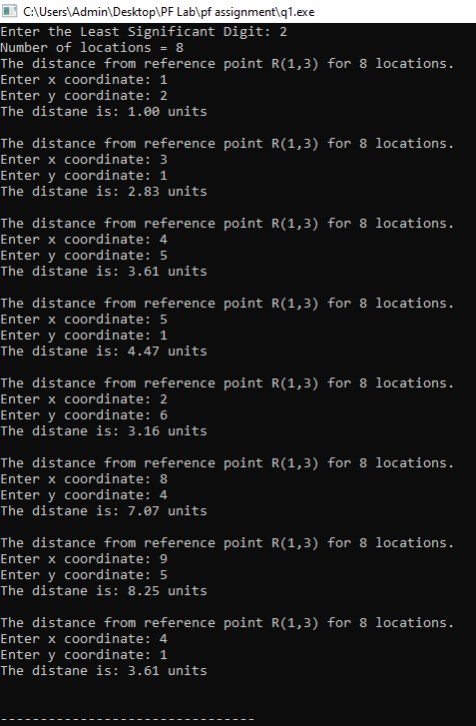

**Question: 2**

Covid’19 vaccinations have become a mandatory requirement for many things such as traveling, bank account opening, admissions in higher educational universities, and many more. Develop a C- script that facilitates the hospital in determining which person needs to be vaccinated based on age and underlying disease. The program should run for N persons and perform the followings: (N should be taken as a user input).

I. if age is greater than or equal to 18 and person belongs to the Urban area of a city then program should display the following message:

**Eligible for the vaccine. Kindly proceed for the vaccination**

II. if age is less than 18 and person to the Rural area of a city then program should display the following message

**Not Eligible for the vaccine. Kindly wait for the vaccination**

III. Also list the possibilities in how many ways we can solve the problem.

**ANSWER III)** In this problem we can use different loops such as for loop or do while loop. We can also use Switch…Case… but we have to use IF…ELSE… inside it to control the decision as switch case does not allow relational operators.

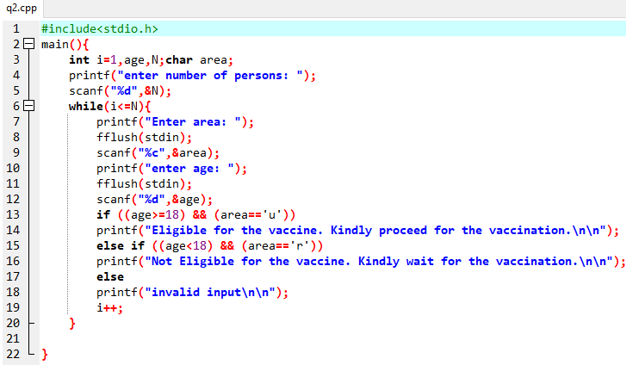

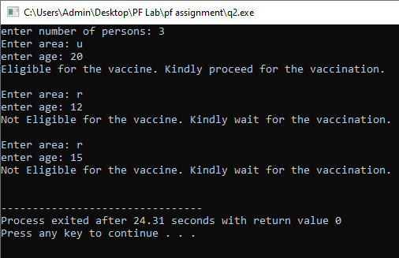

**Question: 3**

Alice and Bob want to exchange the n- digits message on the internet, but they want to ensure the security. They went to a cyber-security specialist Edwin for the solution. Edwin listened to the requirement of the clients and proposed a scheme for cryptography, which is mentioned in following points.

1. The algorithm would reverse the message

2. After reverting the message, it would determine an alphabetic character against the digit. For example, for 0 it would be A, for 1 it would be B, for 2 it would be C, for Z it would be 25. Write a code in C for the above cryptographic algorithm using loops in C for Edwin.

3. Also provide the solution for decryption the message. (System should ask user for encryption and decryption at the start of the program)

**Done on next page**

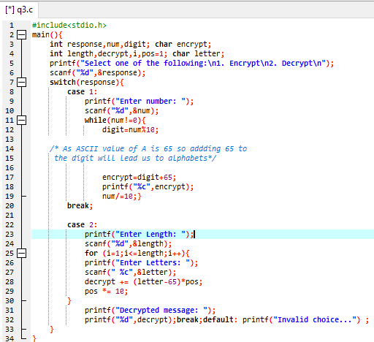

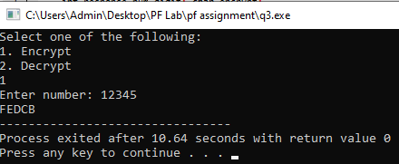

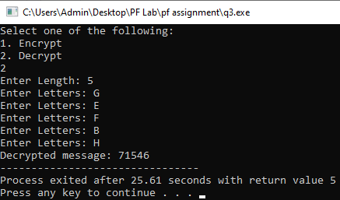

**Question: 4**

A robotics and technological center offer various training and workshop sessions to the registered members. The robotics center has implemented chat bot at the main entrance for checking the membership status of the people. The chat bot is incorporated with the AI- enabling logics to check the membership status. The chat bot system displays 4-digit message randomly on the screen and after reading the message user would type the output….

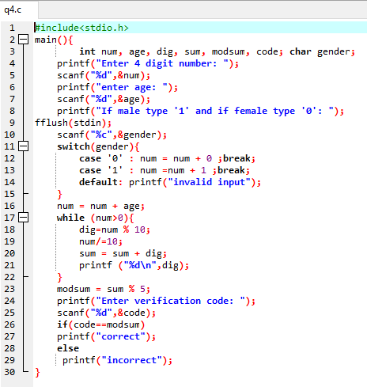

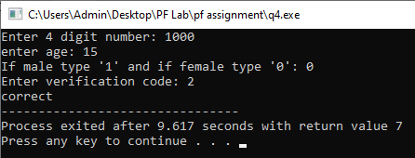

**Question 5**

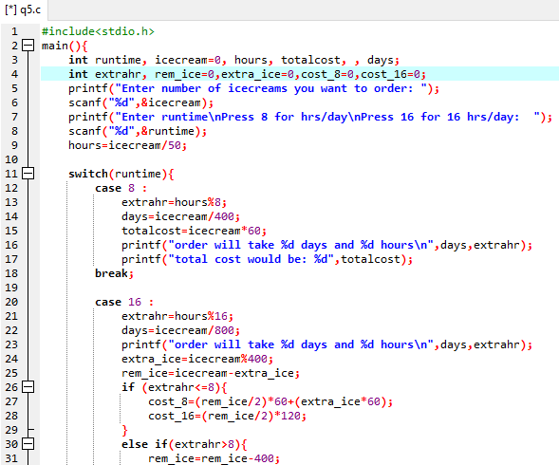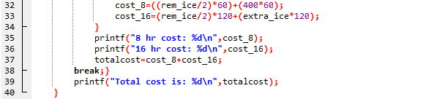Write a program for an ice-cream manufacturing company. Assuming that 50 ice-creams can be prepared each hour whereas each Ice-cream costs 60Rs. The plant operates 8hrs per day but can have operating ability of 16hrs per day. But for another 8-hrs, the cost of each ice-cream would be doubled. You have to implement a method that identifies whether you want the plant to run 8hrs or 16 hrs. per day. Each ice-cream’s cost is fixed. You have to calculate how many days and hours it will take to produce any number of ice-creams and what would be the cost. Write a program that asks the user for the number of ice-creams that have been ordered and also whether the person required the plant to run 16hrs or 8 hrs. per day and then displays the bill for the customer that indicate the number of days and hours it will take to produce them and also the total cost of ice-creams along with their cost distribution based on plant-running time.

**OUTPUT ON NEXT PAGE**

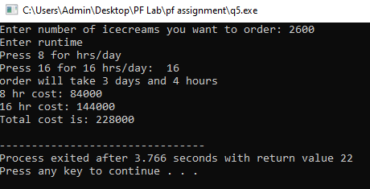

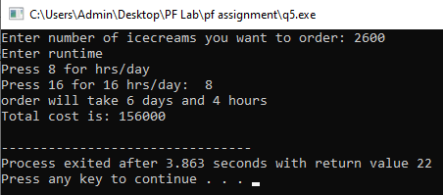

**Question 6**

An unarmed vehicle (UAV) is operating in a smart environment where it is communicating with a mobile device and a self-driving car (refer Fig.2 Drone Alpha). The UAV is equipped with an AI facility, and it displays the pattern A when it communicates with the SD. On the other hand, it shows pattern B when it starts communication with the mobile device. Develop a C-script that is needed to be integrated into UAV, which generates pattern A (refer fig.2) for SD car and pattern B (refer fig.2) for mobile device.

Input: Iterations

s = communicating with SD

m = communicating with mobile

Output: Pattern A when communicating with SD or Pattern B when communicating with mobile device

**Done on next page**

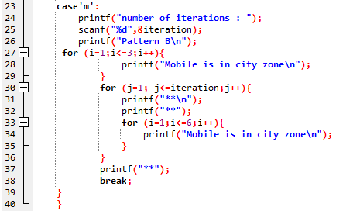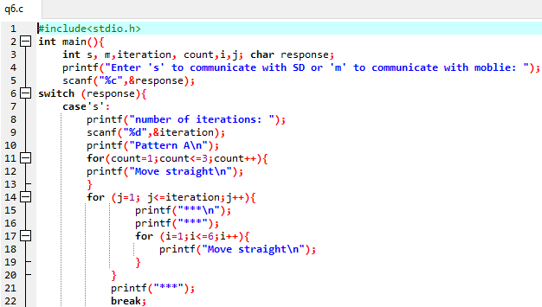

**OUTPUT ON NEXT PAGE**

